

USER MANUAL FOR LMS

Developers:

JOEL OBOWU  
Abdel Karim baschirou   
Anold nyato   
Manav patel

kHAWLA eSSAK

**How to login in as an admin, viewing and adding users, and viewing and adding courses:**

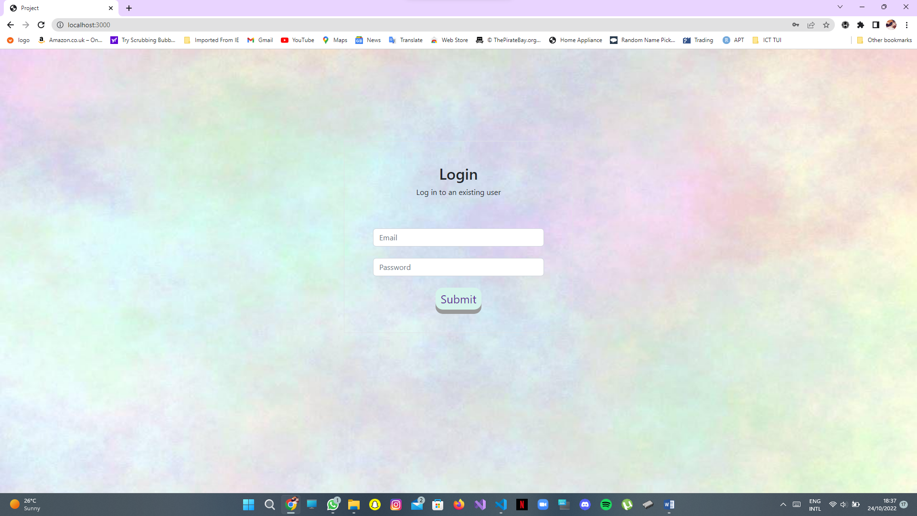

Login Page: - Enter Admin details to login as Admin:

Email: [admin@gmail.com](mailto:admin@gmail.com)

Password: admin123

Press the submit button.

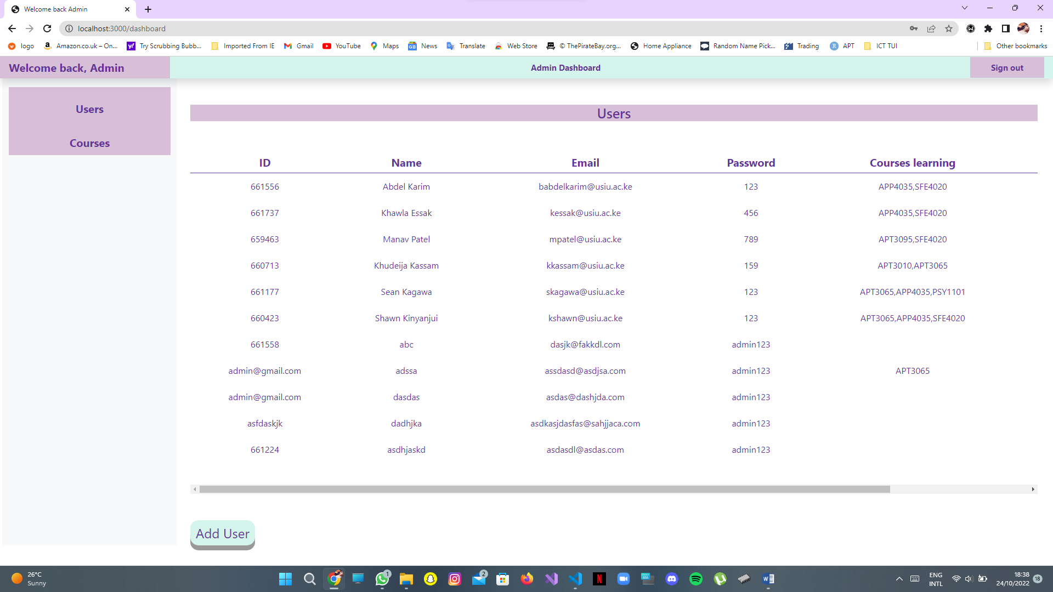

Once you are logged in, you will be led to the User’s page where you can view all users, the details show, the ID, Name, Email, Password, Courses Learning and Courses Teaching as shown above. To view Courses Teaching, scroll the page to the right as shown below.

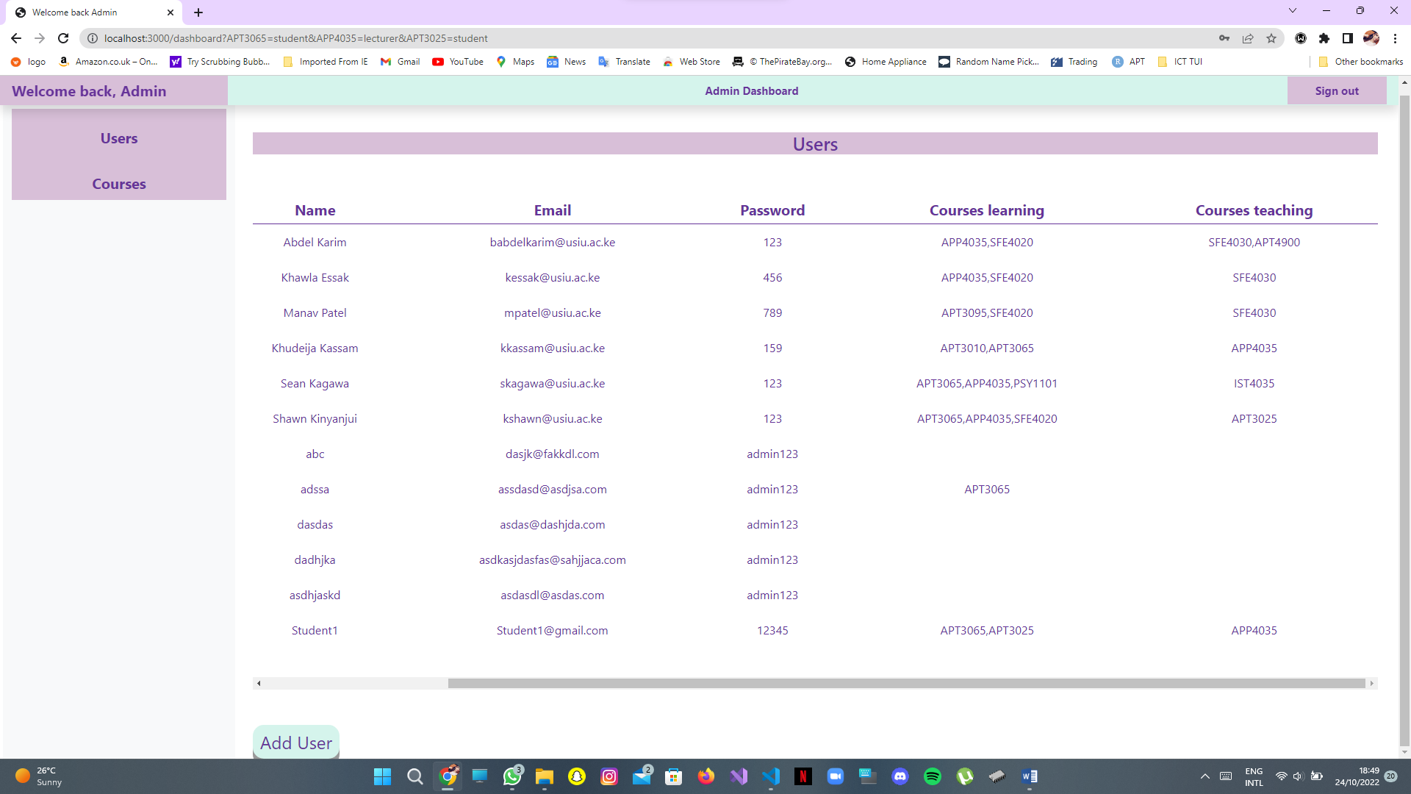



To add a new user, click the Add User button as shown above.

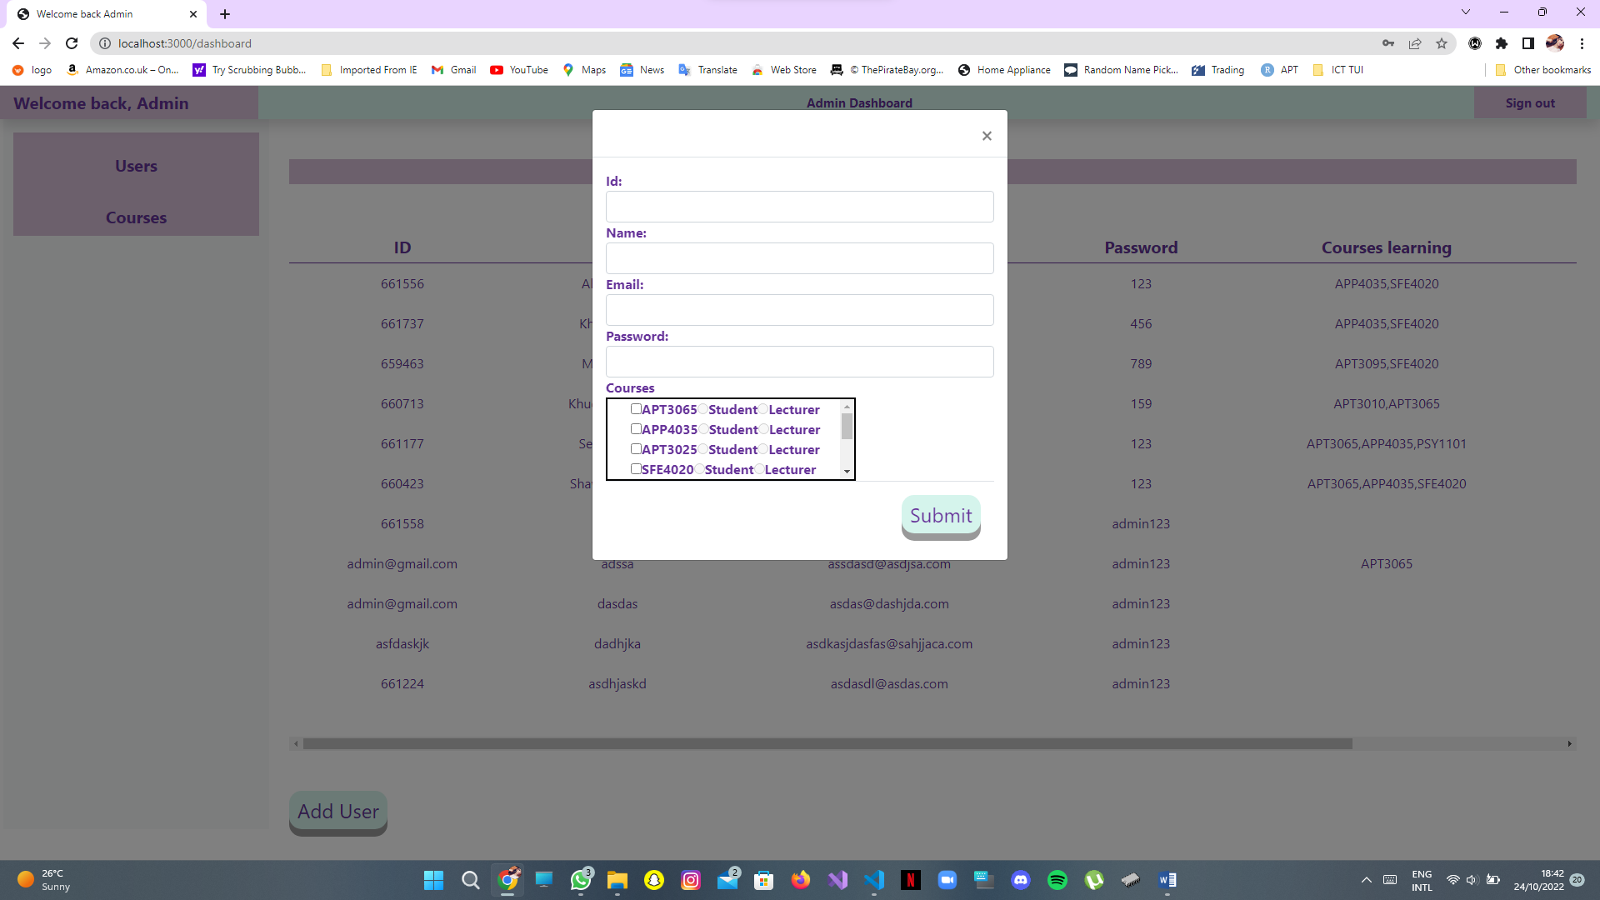

A popup will show up where you can fill in user details. You should enter the ID, Name, Email, and Password. Then you select the courses the user is picking and whether they will be a student or a lecturer in that course. Once that information is put in, click the submit button.

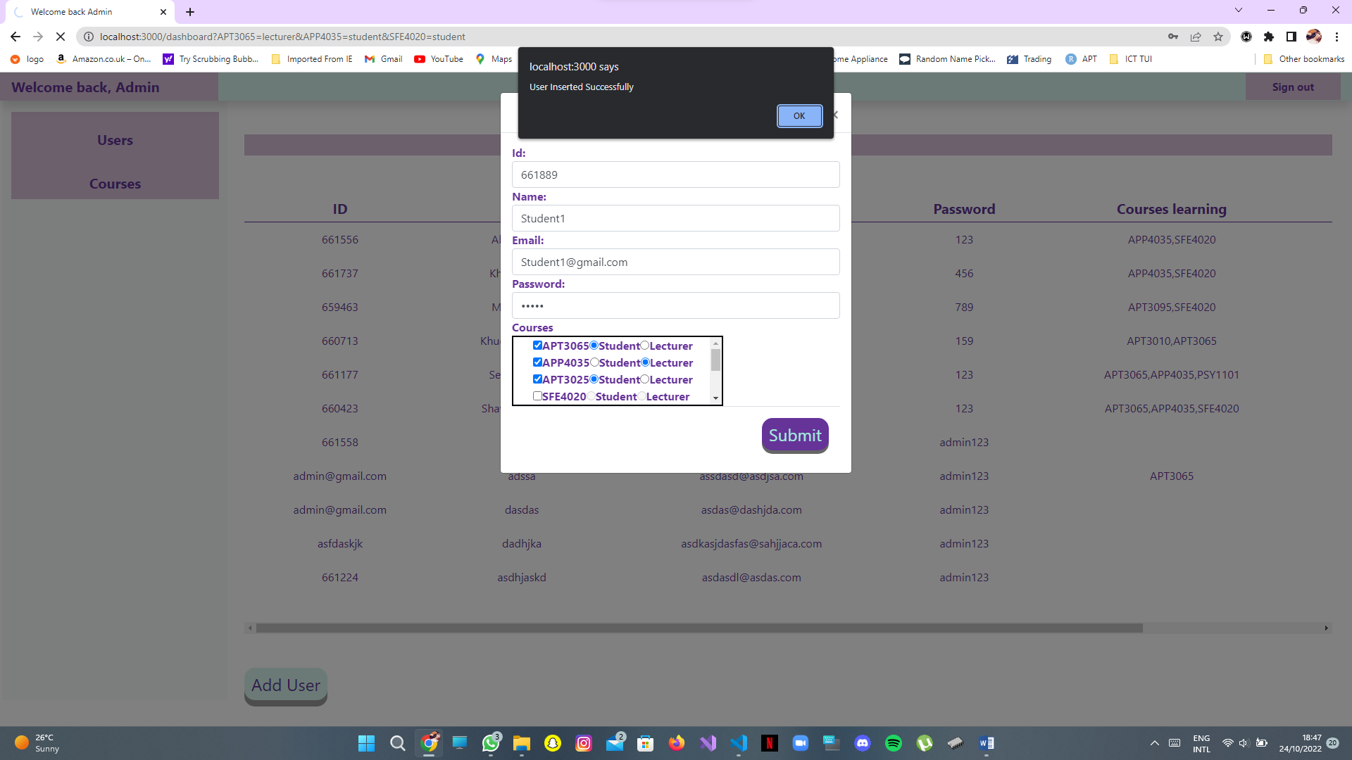

If all the information has been put in correctly, a popup will come up showing that the user has been inserted successfully.

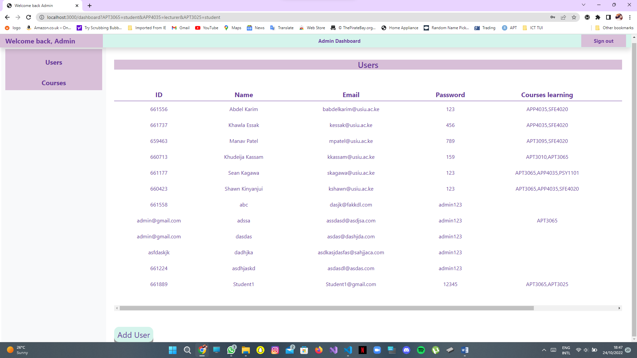

The new user is now added to the list of all the users existing.

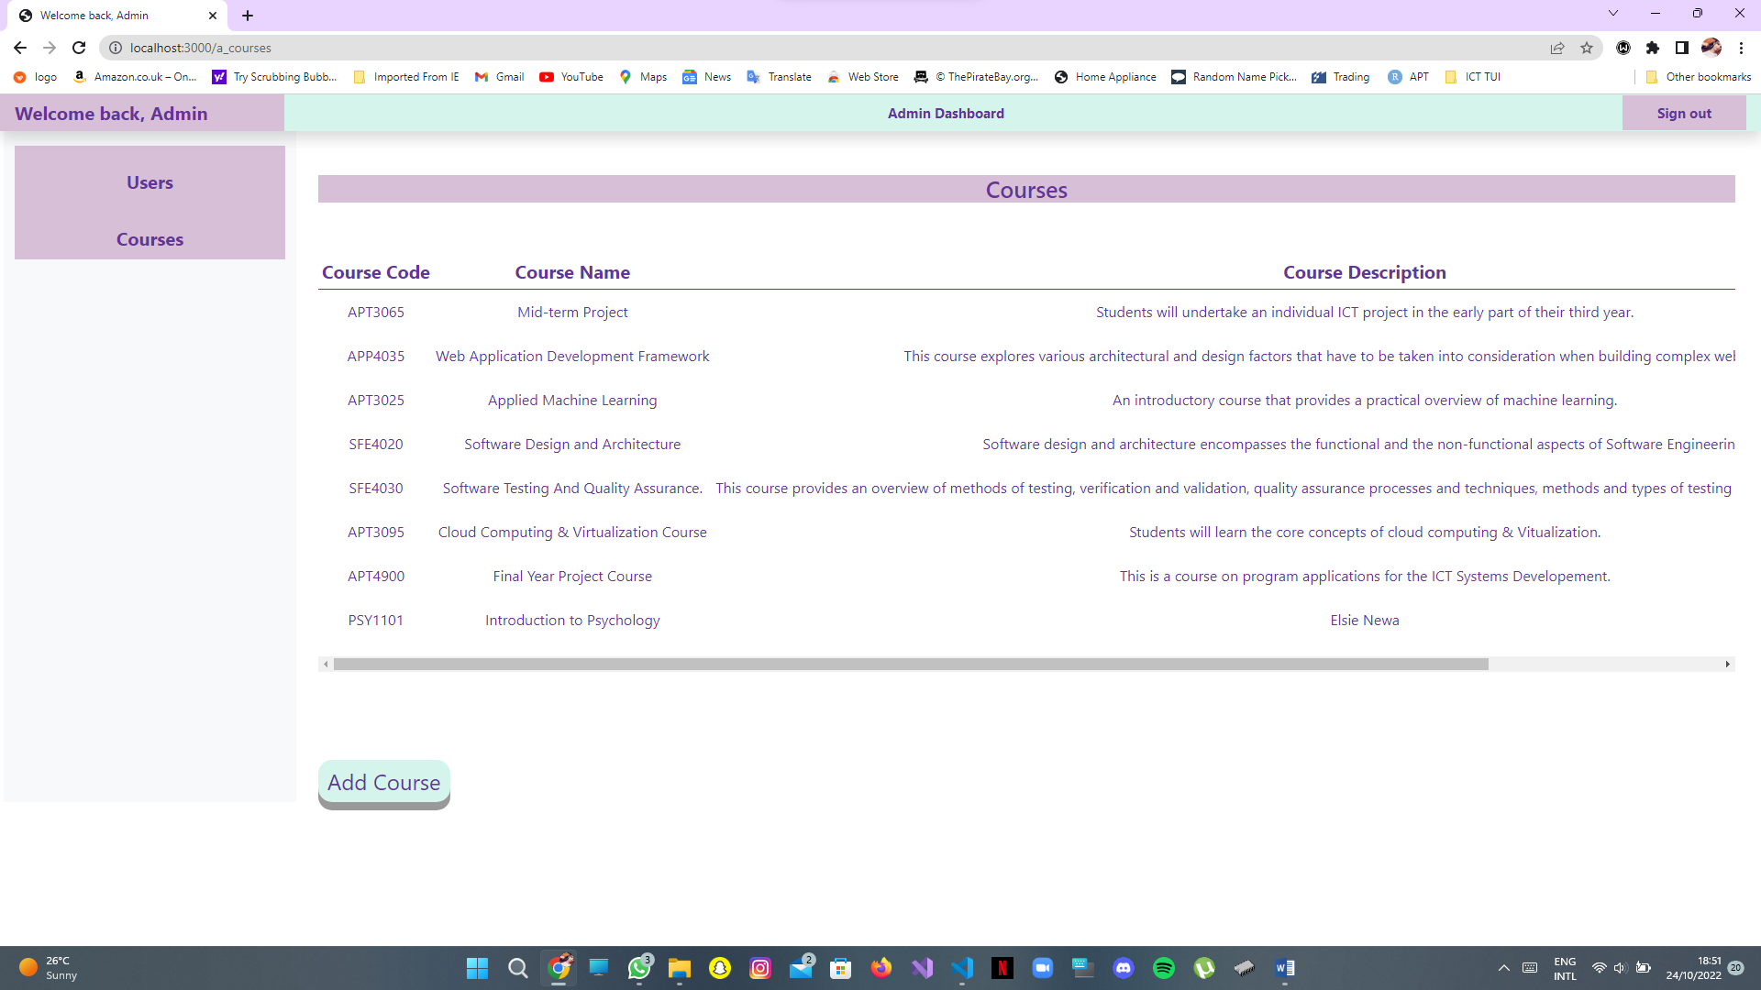

To view the list of courses, click on the section that says courses. Here you can view courses that are available. The details include: Course code, Course Name and Course Description. To add a course click the Add Course button and a popup will show up to enter course information.

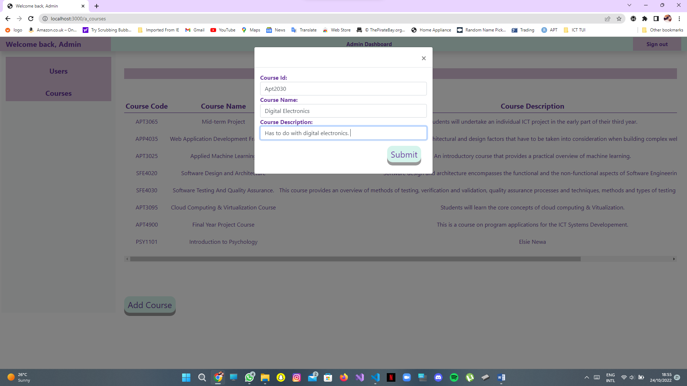

Once you have entered valid details, click on the submit button, and you will see the new course appear in the list of available courses as shown below.

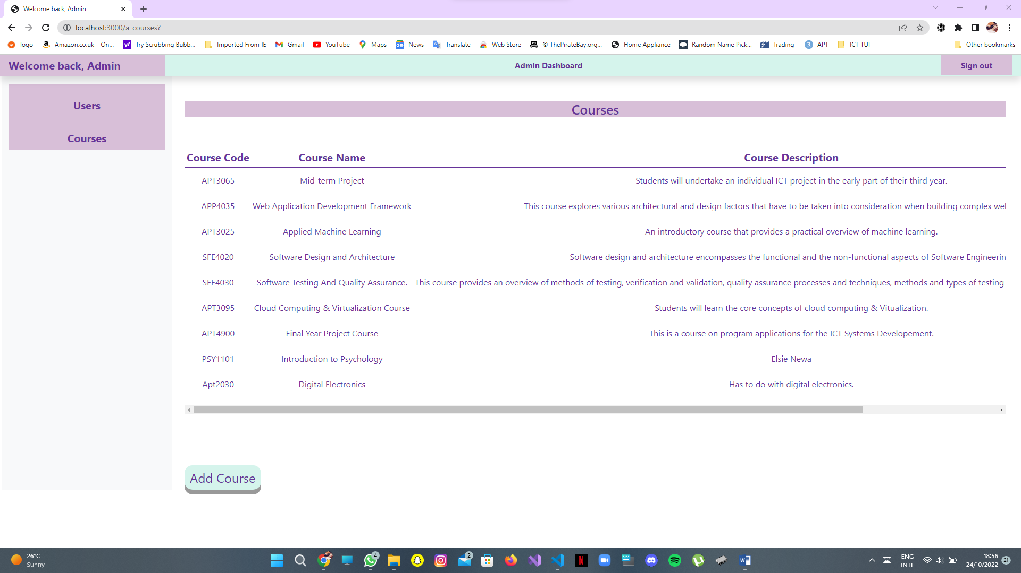



To log out/ sign out, click on the Sign out button and you will be redirected to the login page.

**How to login as a user, view personal details and courses learning and teaching:**

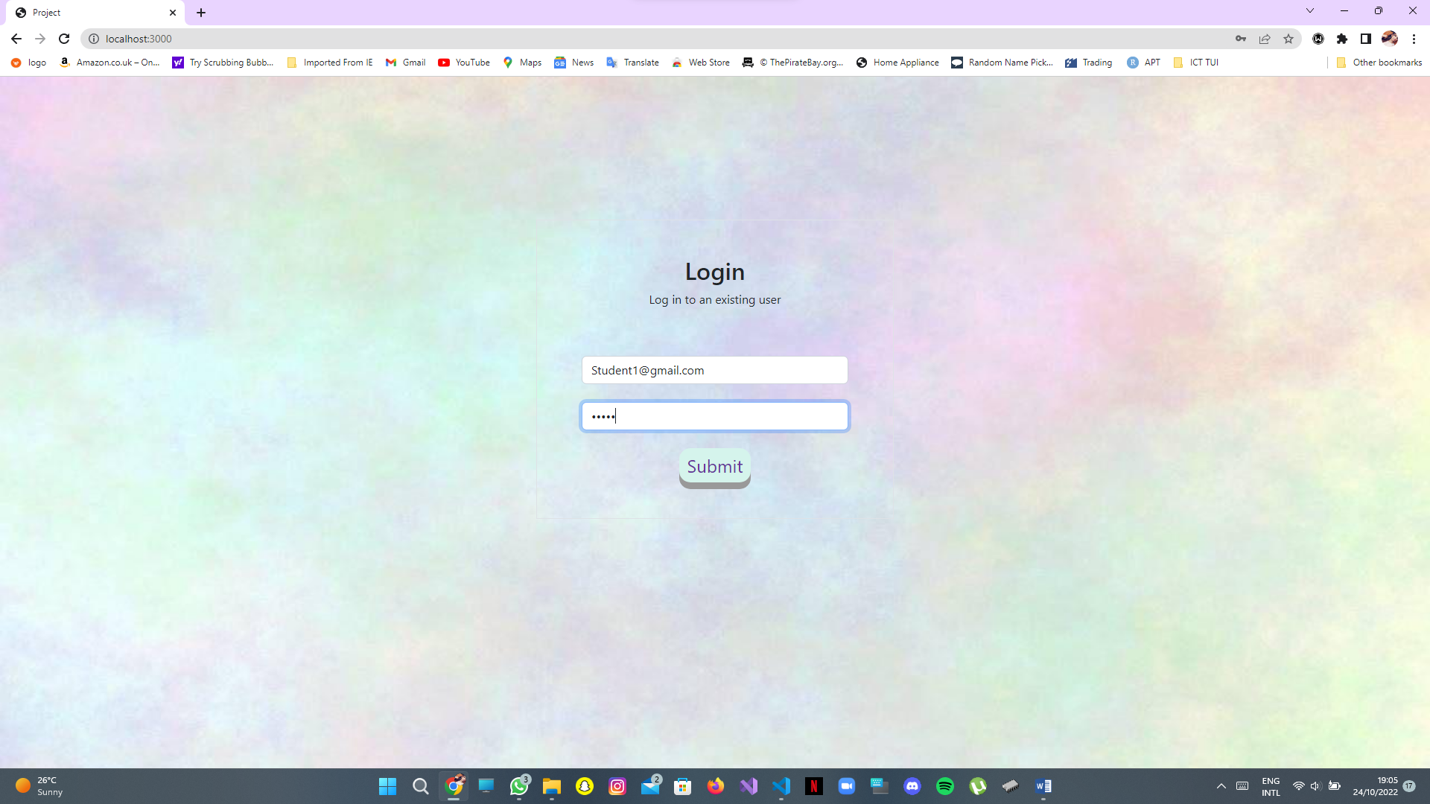

Put in existing user details that have been created by an admin and click the submit button.

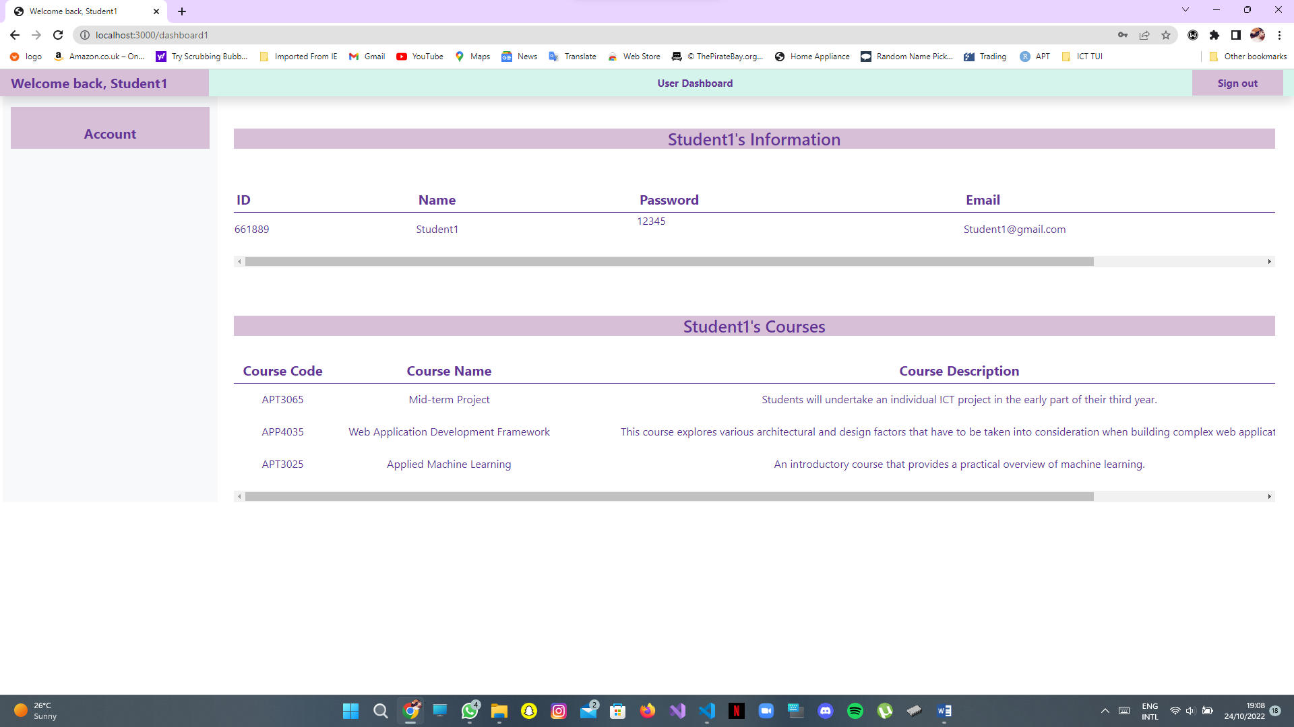

3.

2.

1.

Once you have logged in you will see:

1. Personal information
2. Courses you have as a user

To view the kind of user you are (student/lecturer) scroll to the right as shown above (3.)

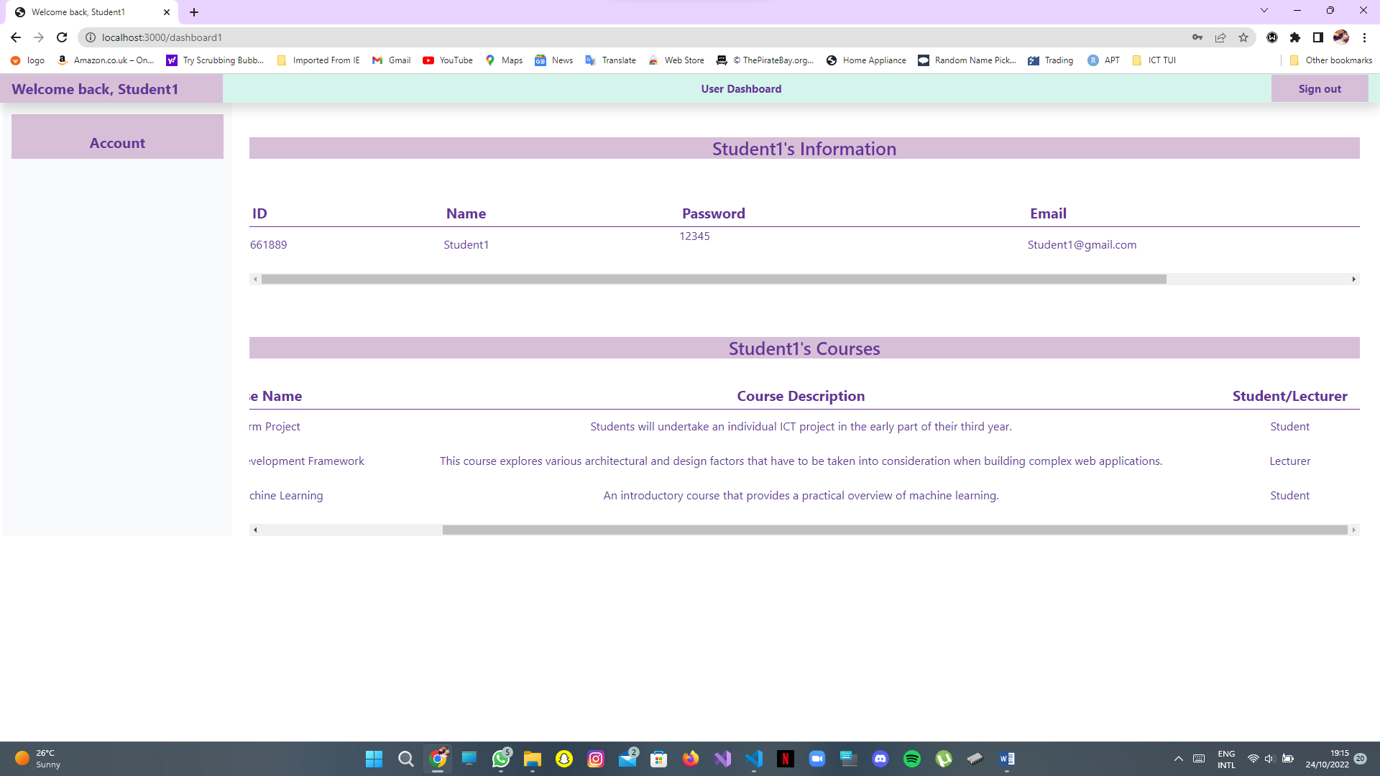

Once you scroll to the right, you can view the type of user you are in the different courses.



To sign out, click on the sign out button.